MA322 – Scientific Computing Laboratory

Lab – 14

Dipanshu Goyal 210123083

# Ques – 1

By using the five-point stencil method, the given BVPs are estimated and the linear algebraic equations formed in the process are solved directly by forming a matrix and solving Ax = b i.e. x = A-1b.

Then the following 4 plots are plotted accordingly: -

* Surface and Contour plots of approximate solutions.
* Surface and Contour plots of Exact Solutions.
* Surface plot of Errors.
* delx vs Max Error plot on loglog scale.

1. For h = 0.25

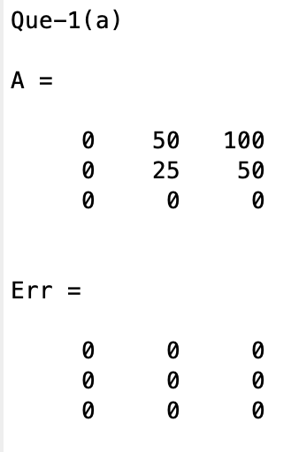

Here in matrix A, x is increasing from left to right and y is increasing from bottom to top.

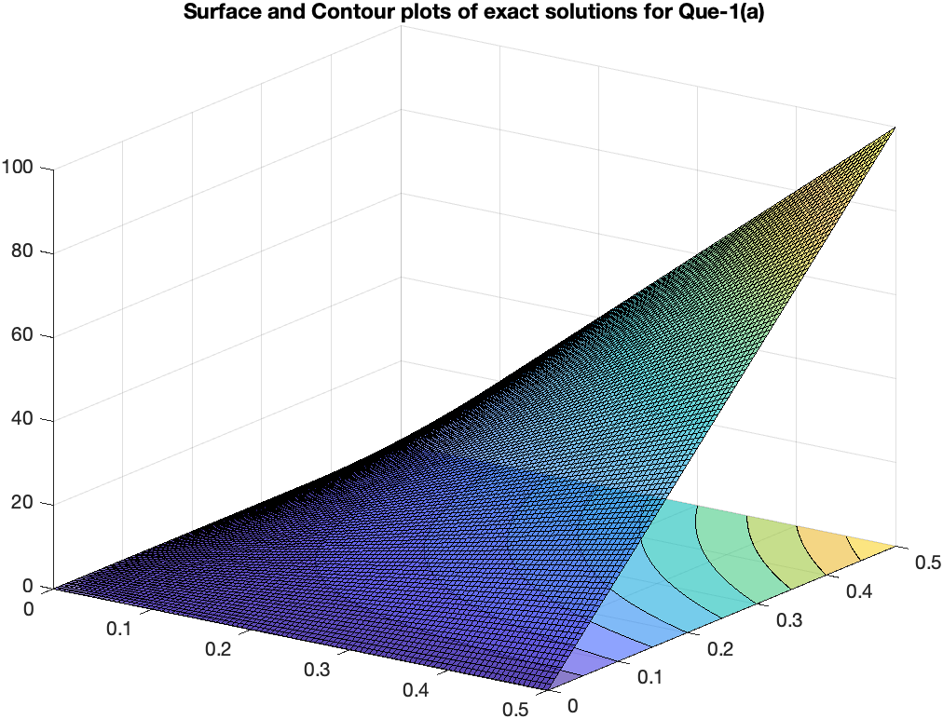 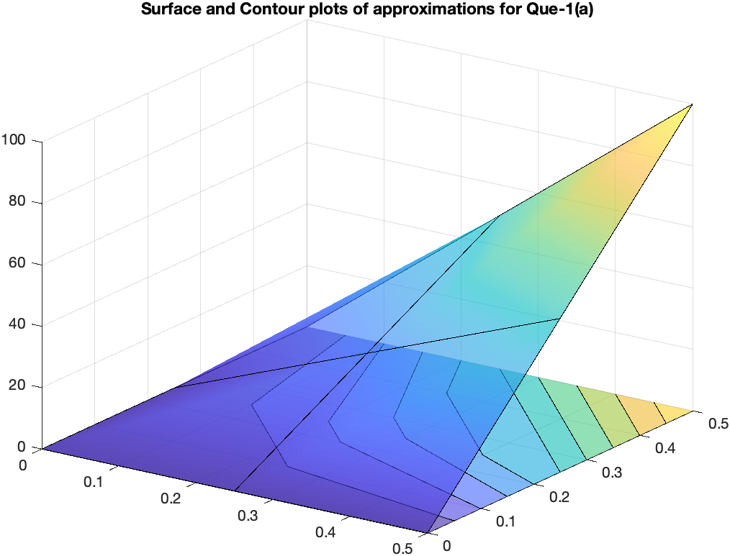

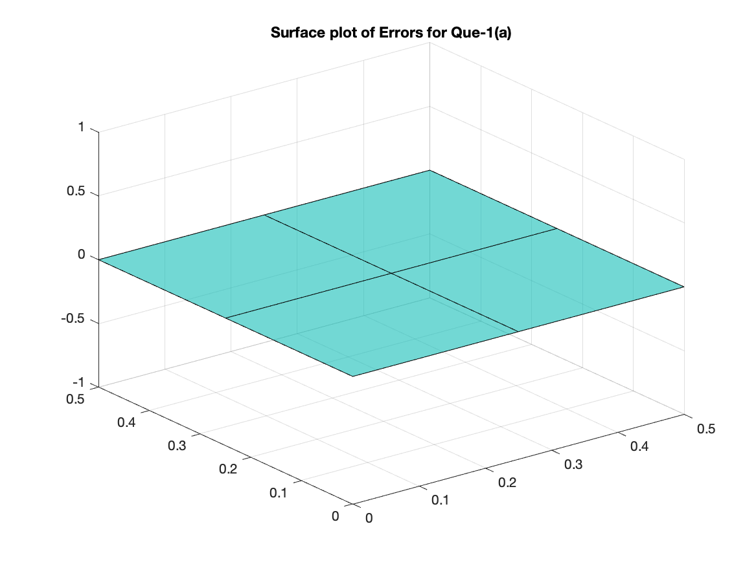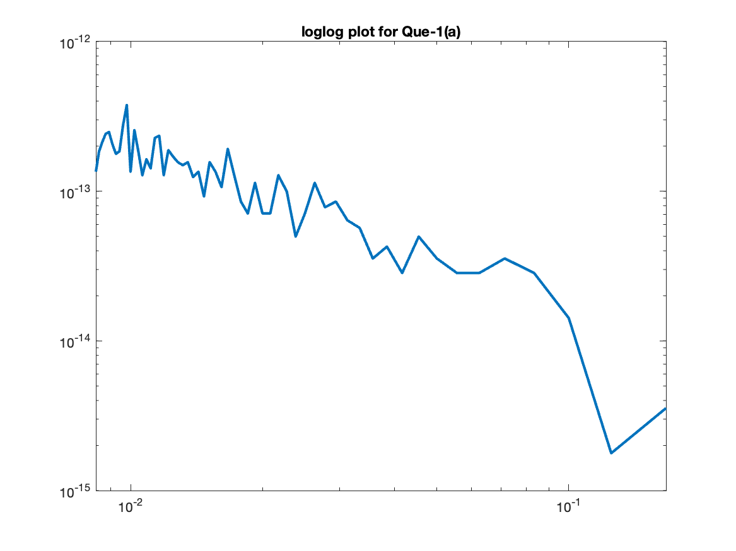

1. For h = 0.2

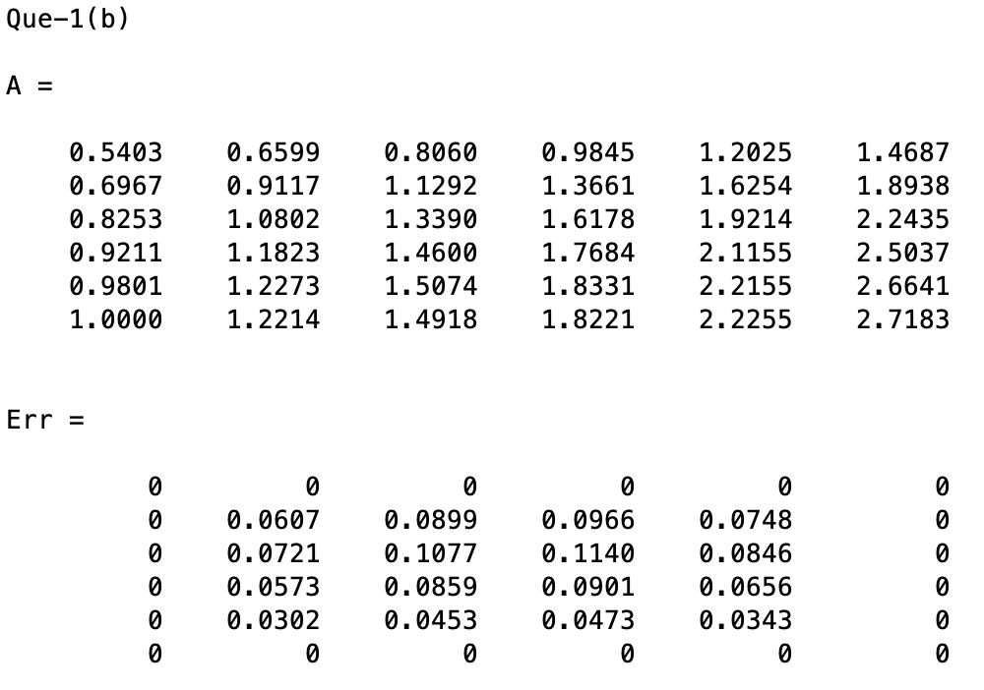

Here also, for matrix A, the x and y increase in same direction as (a) part.

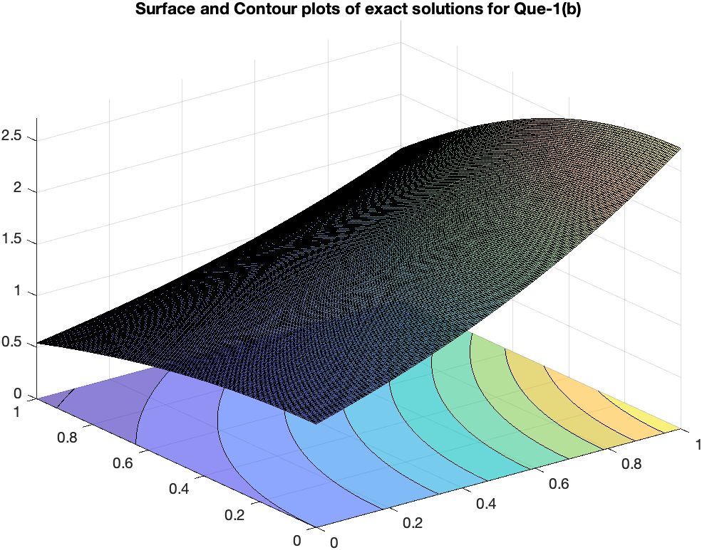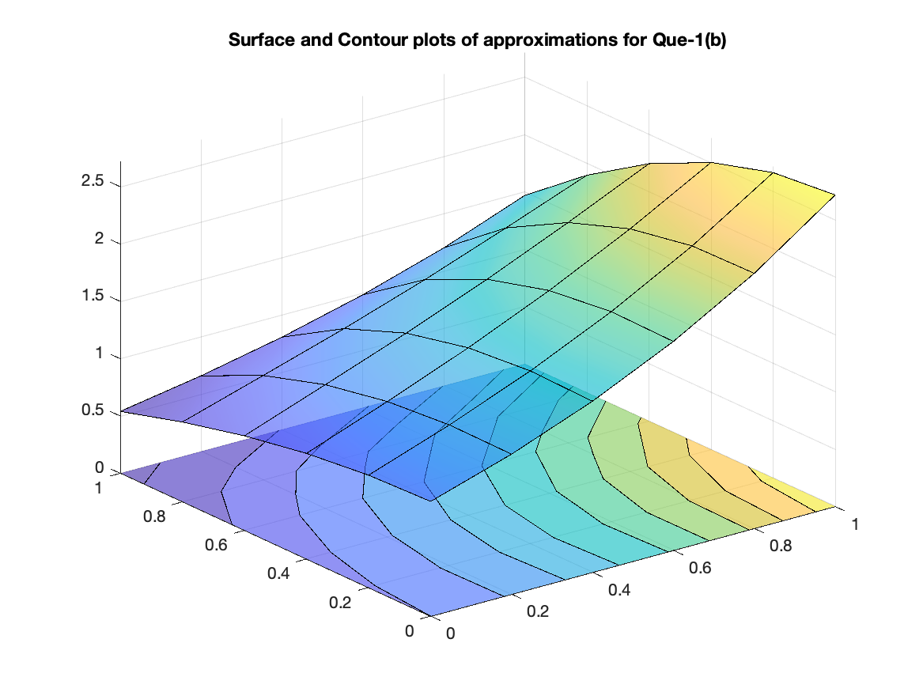

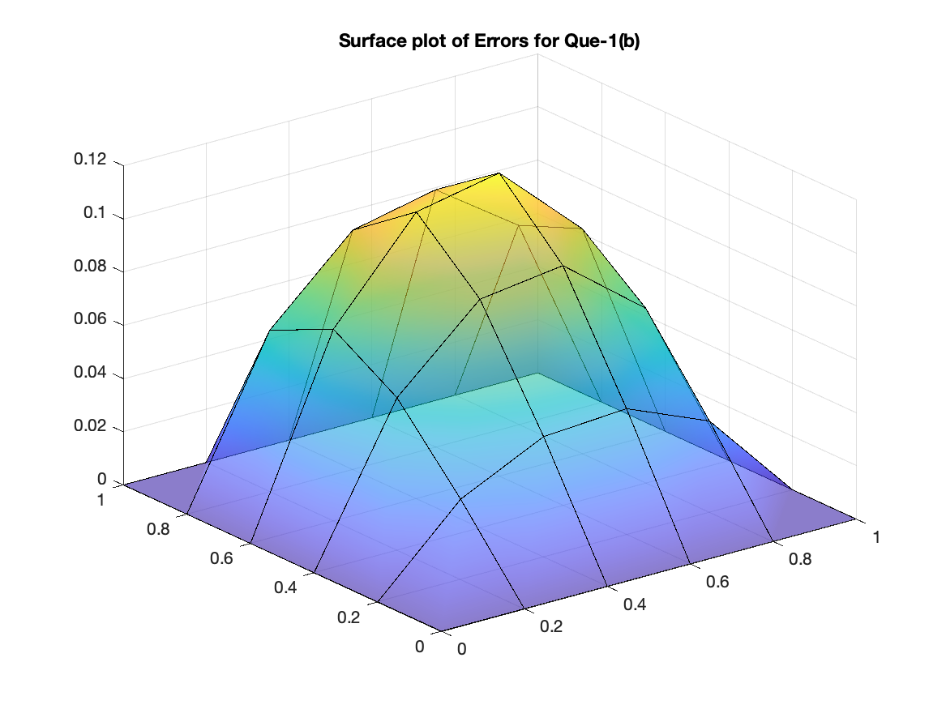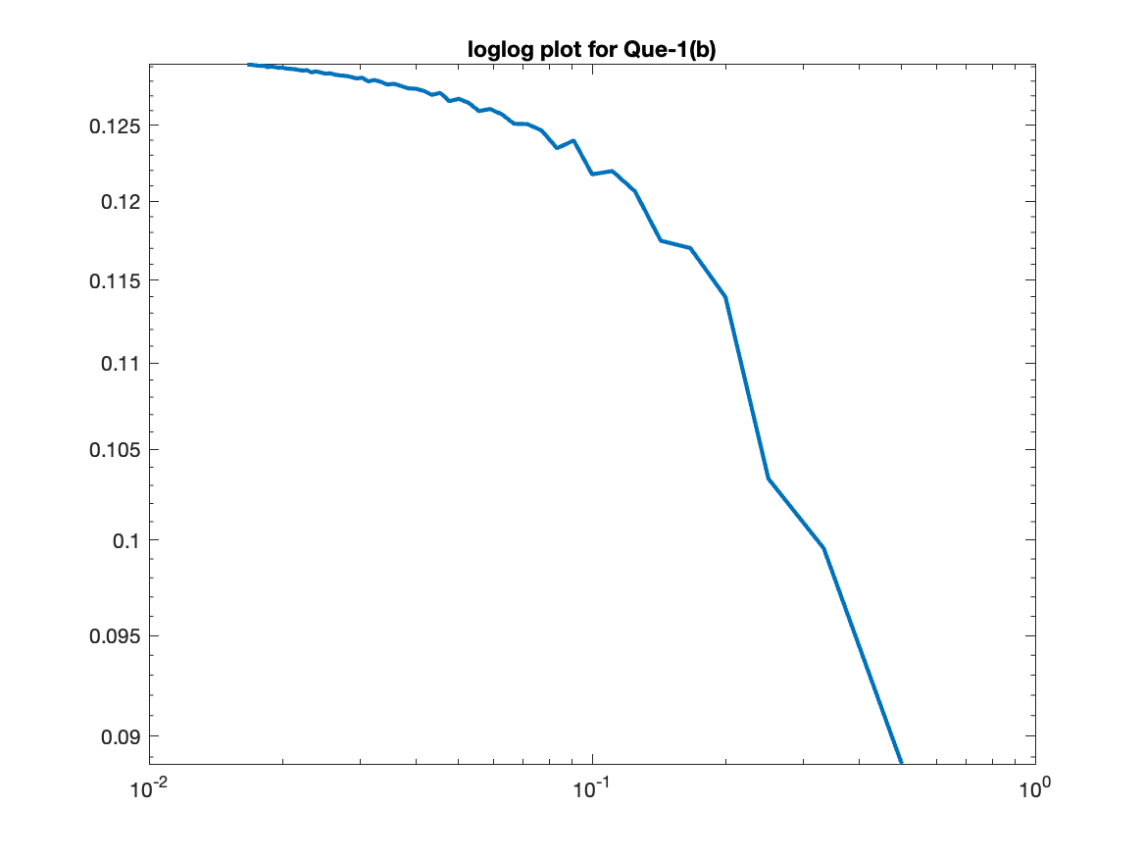

# Ques – 2

The equations obtained in Question-1 are solved by Gauss-Seidel method here for both parts taking a maximum number of iterations as 1000.

1. For h = 0.25

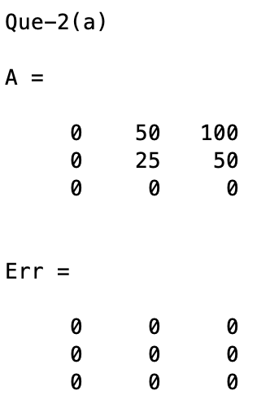

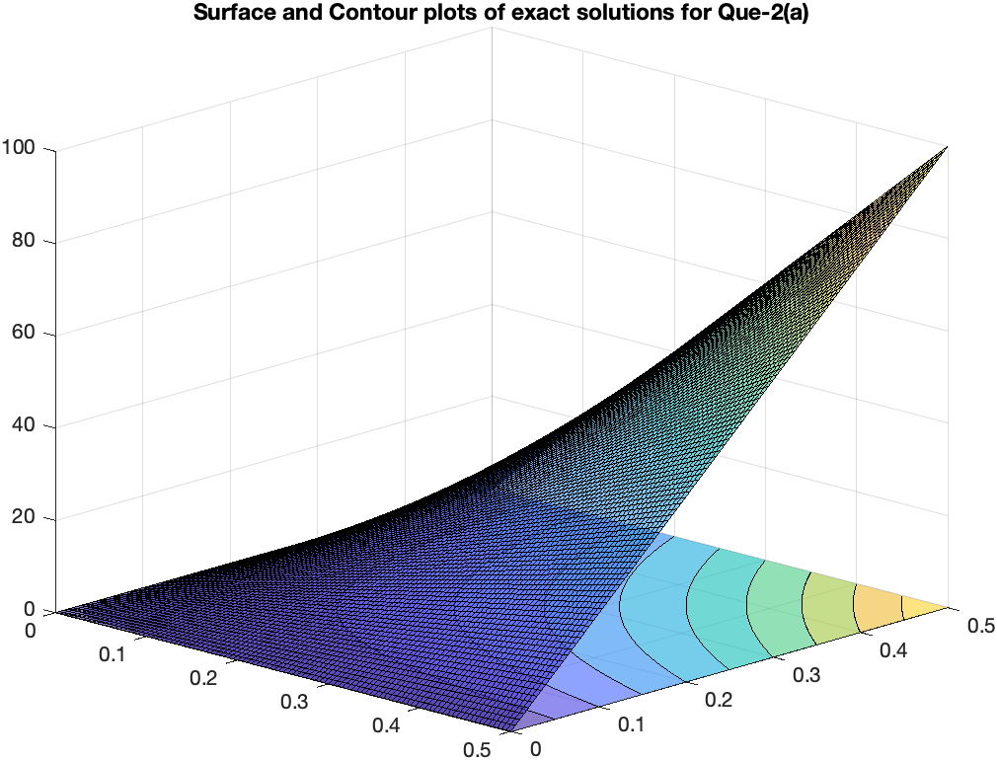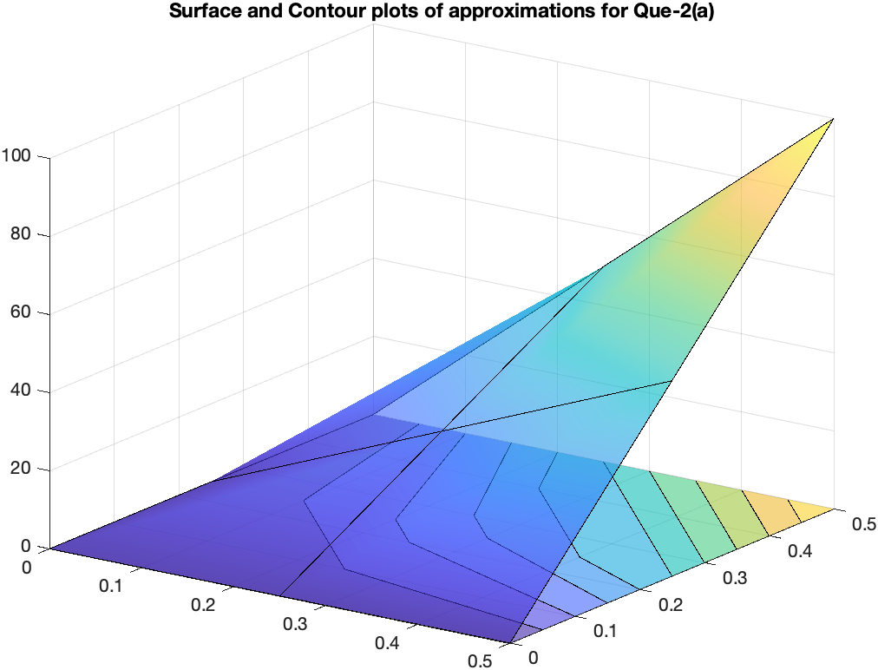

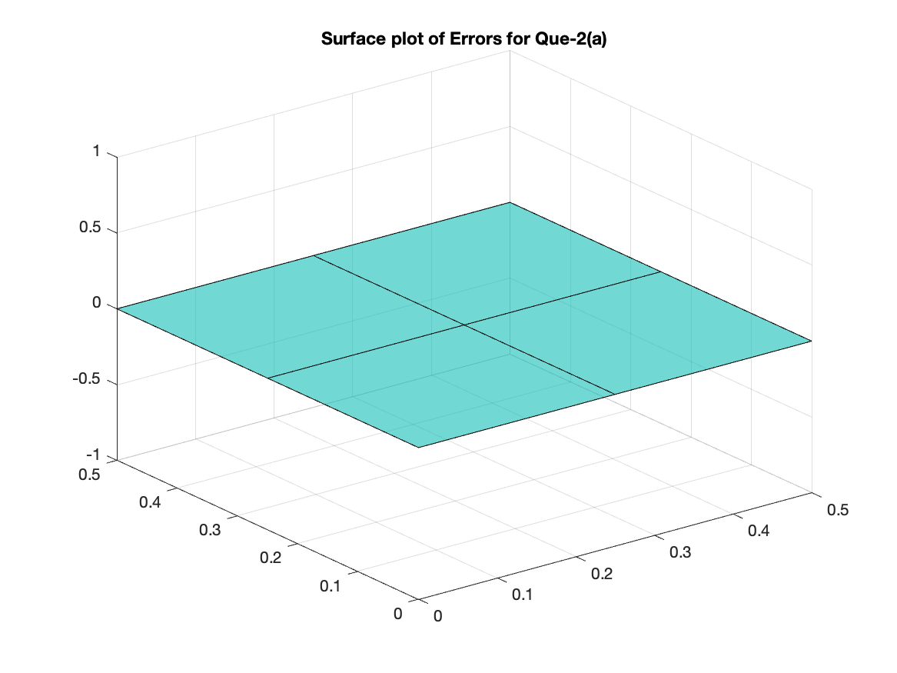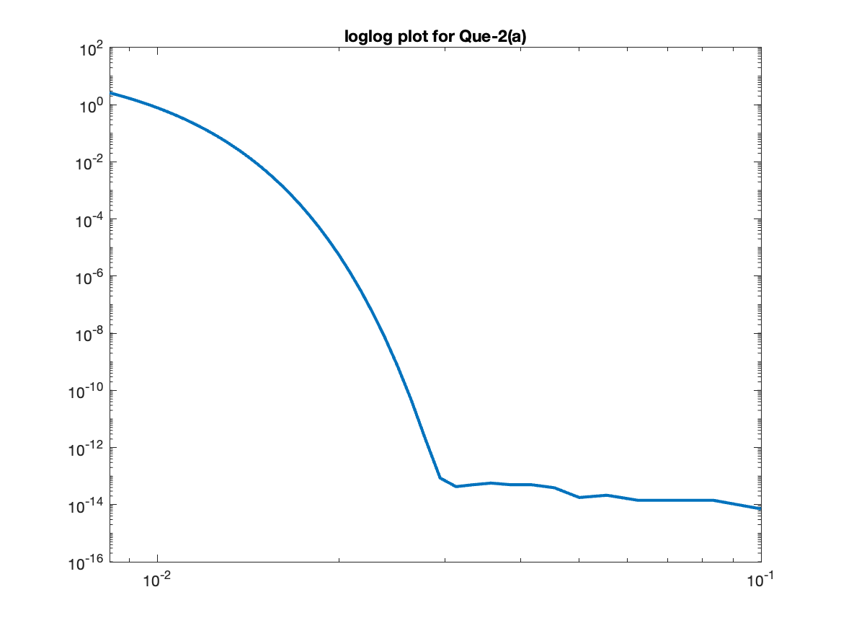

1. For h = 0.2

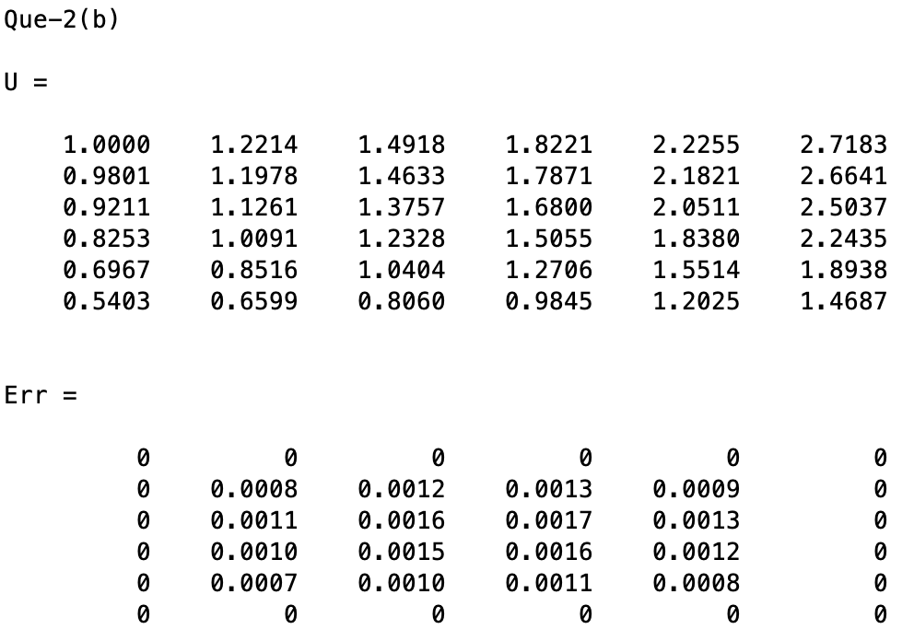

Here, for part (b) y axis in matrix U is increasing from top to bottom unlike before.

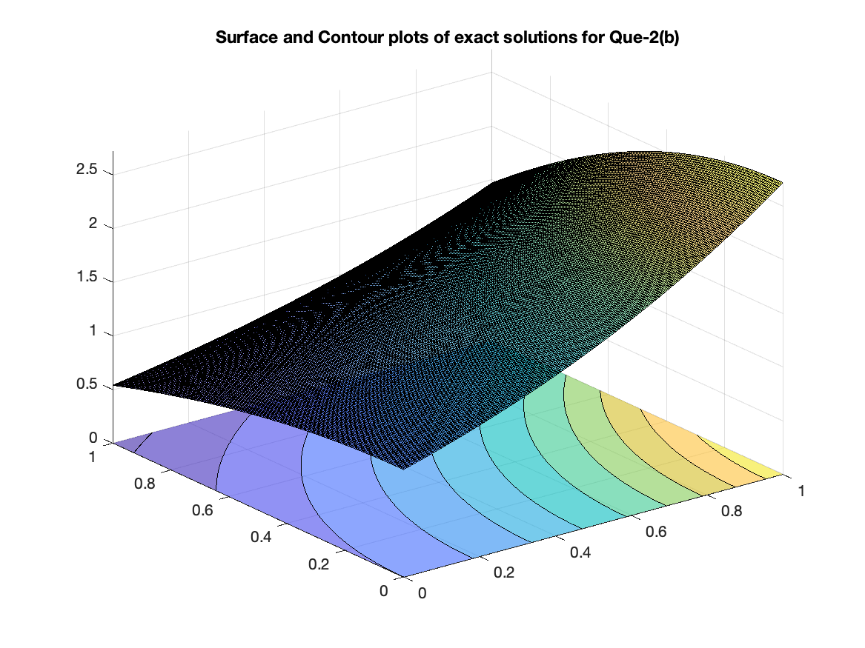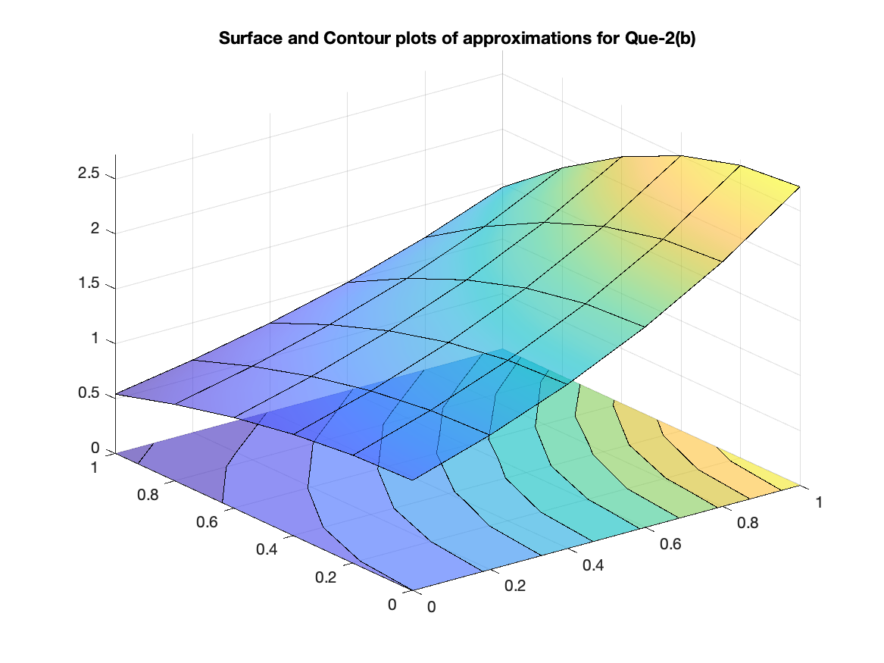

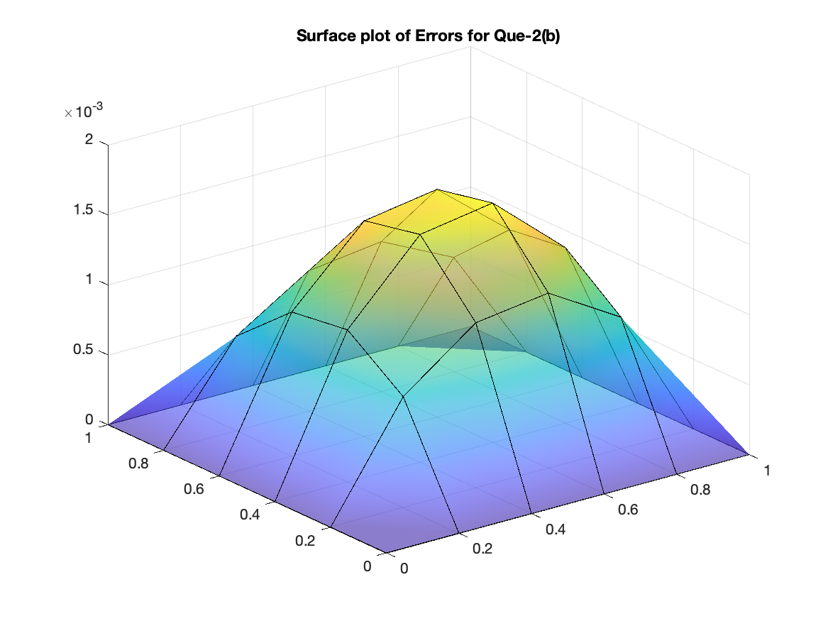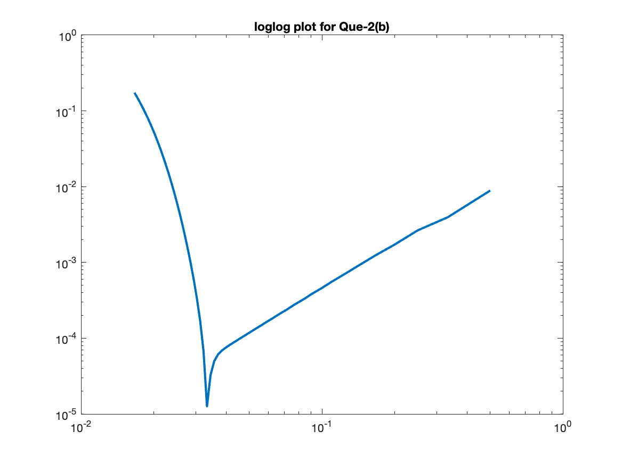

# Ques – 3

The equations obtained in Question-1 are solved by Jacobi method here for both parts taking a maximum number of iterations as 1000.

1. For h = 0.25

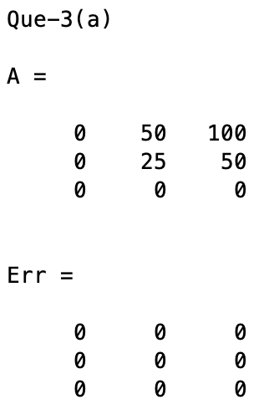

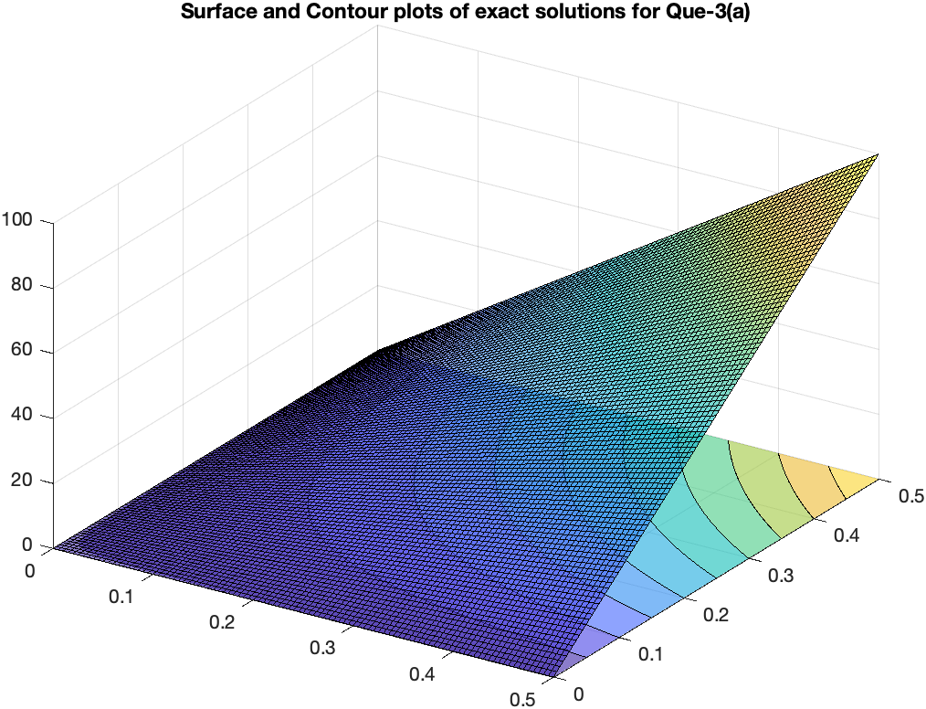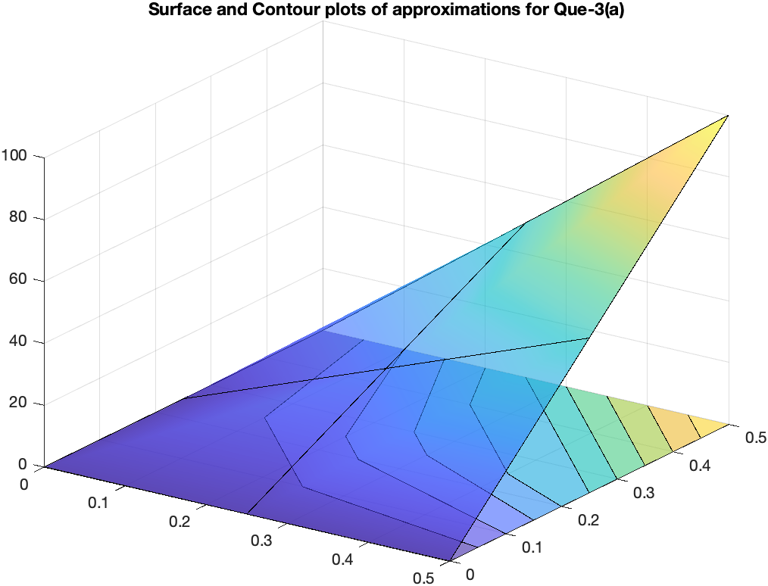

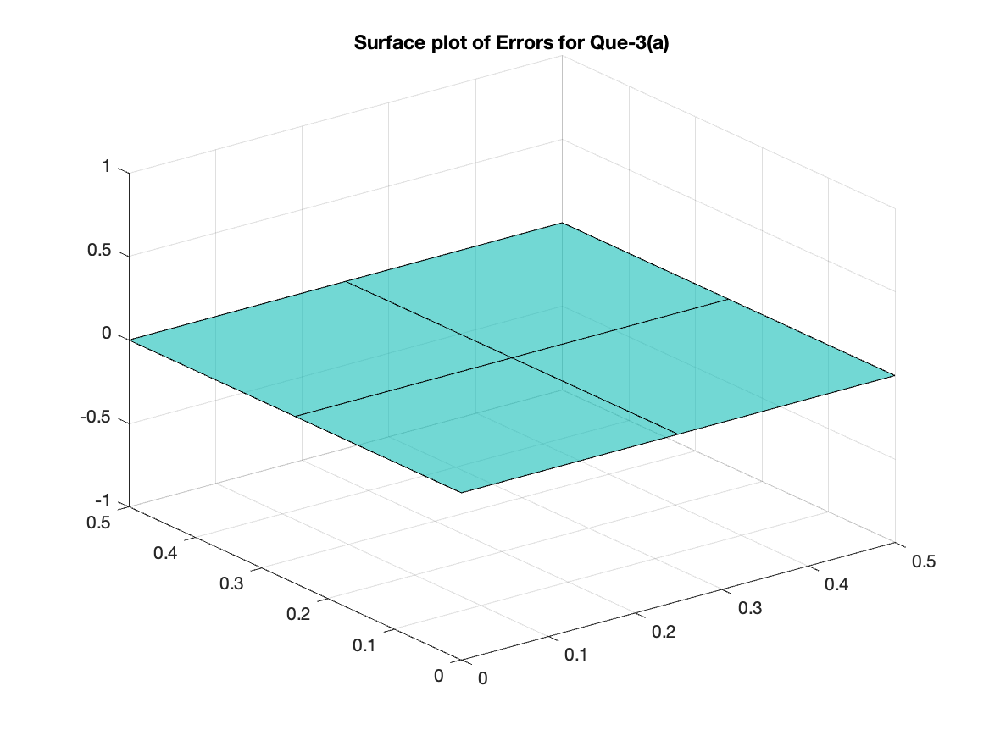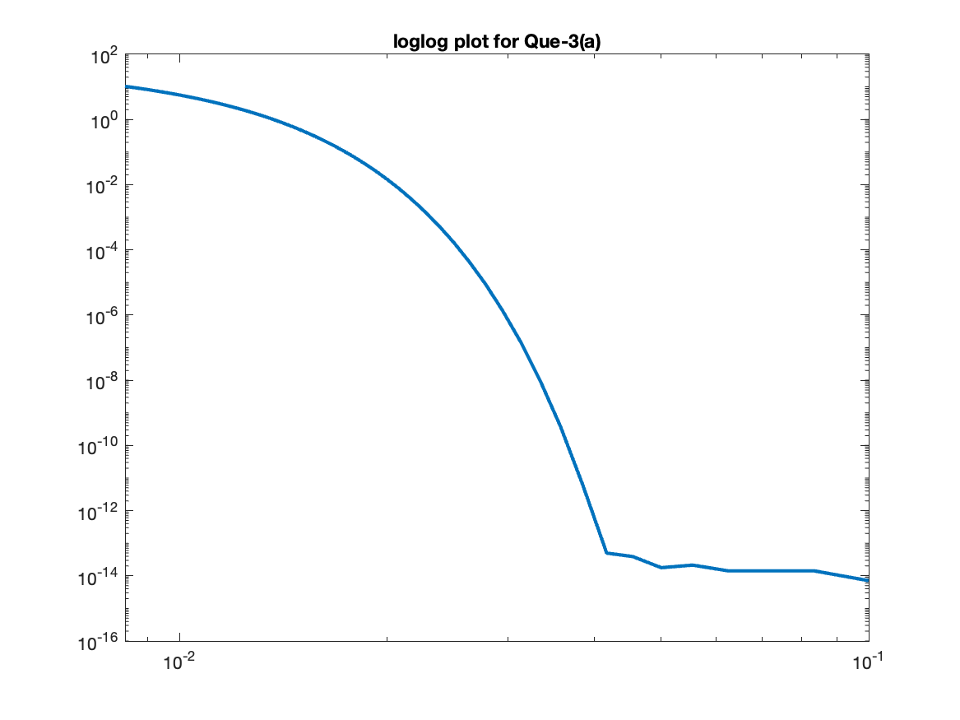

1. For h = 0.2

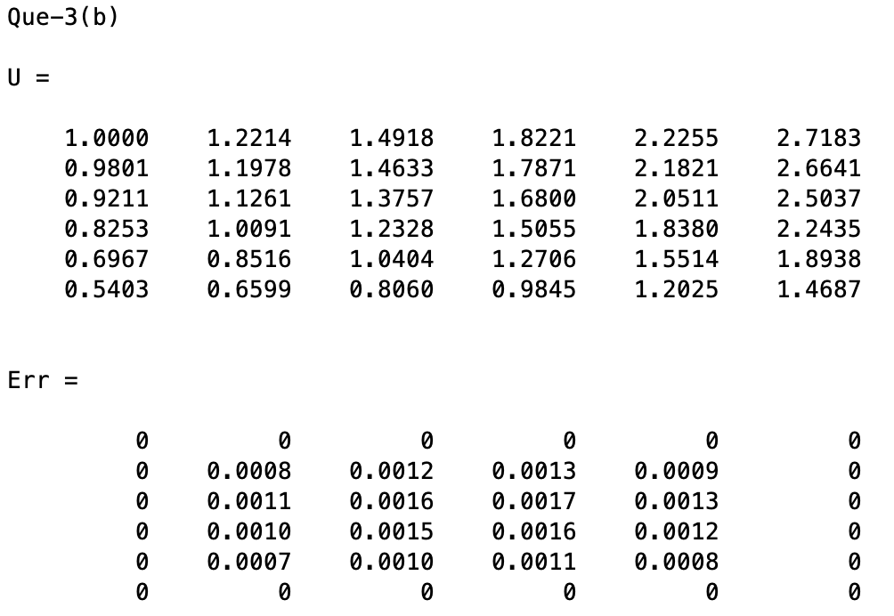

Here, just like Question-2, x is increasing from left to right in all matrices while y is increasing from top to bottom in part (b) and from bottom to top in part (a).

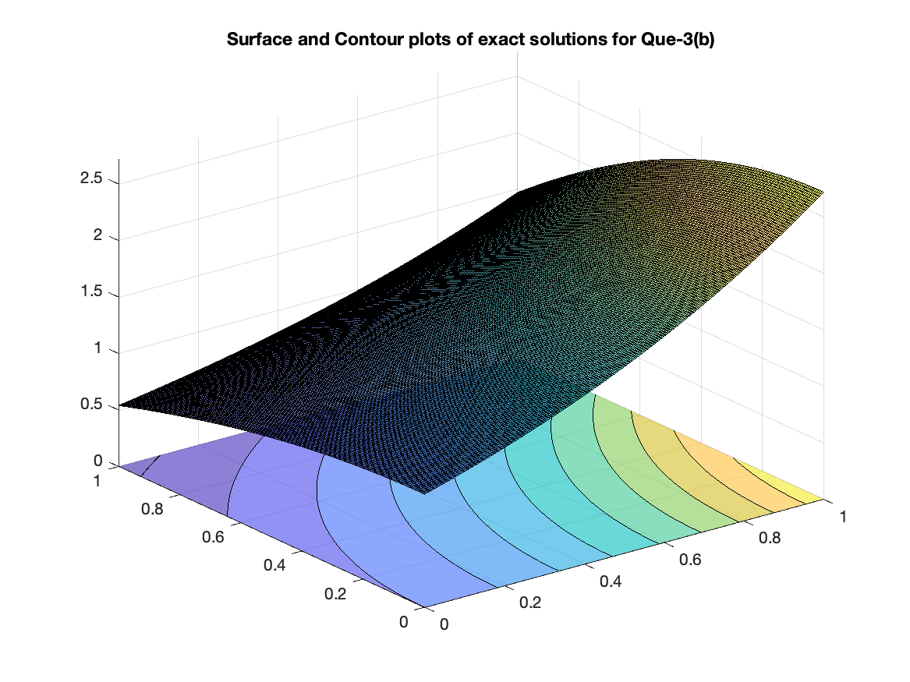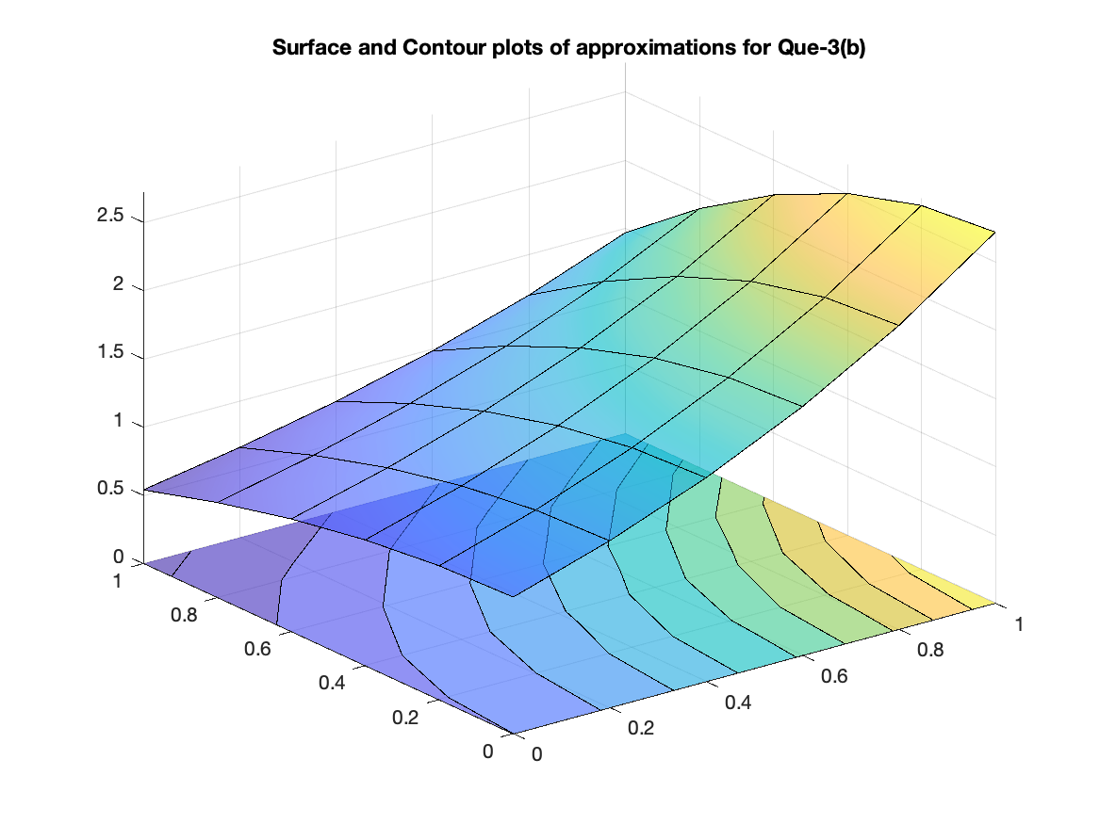

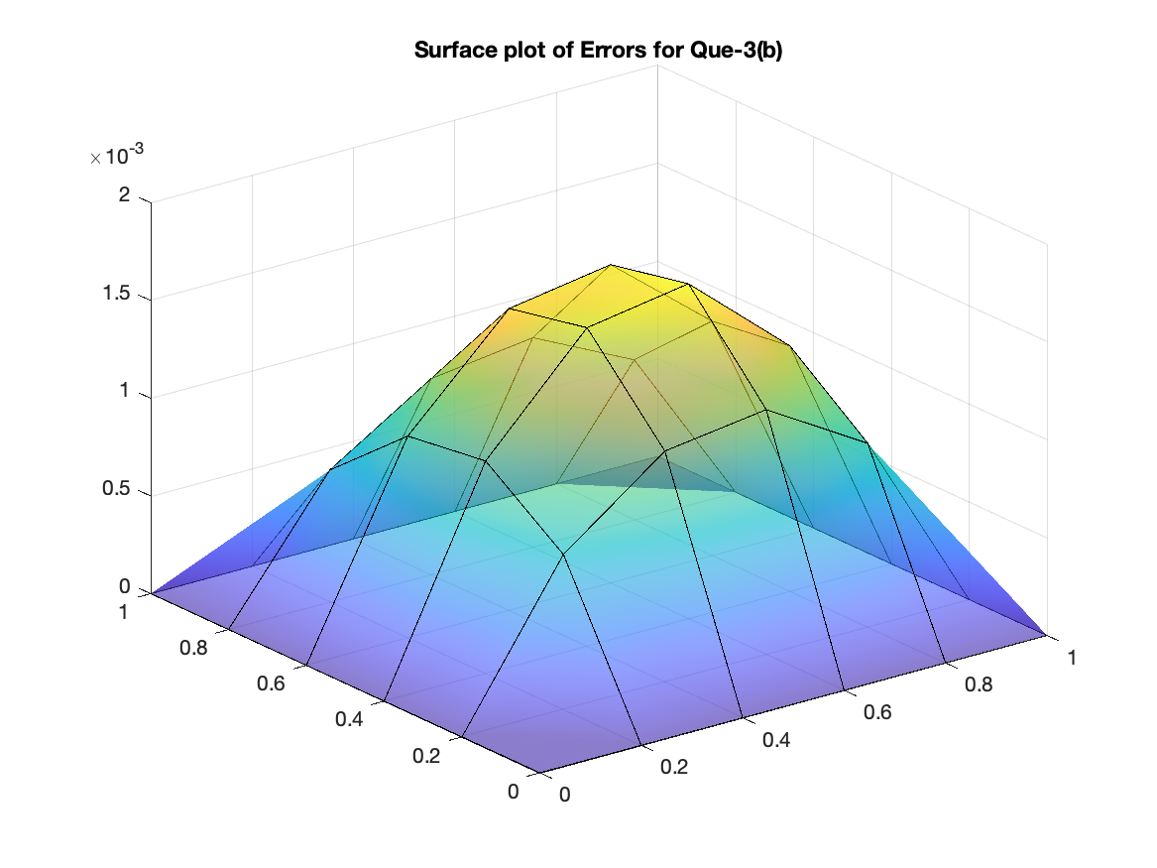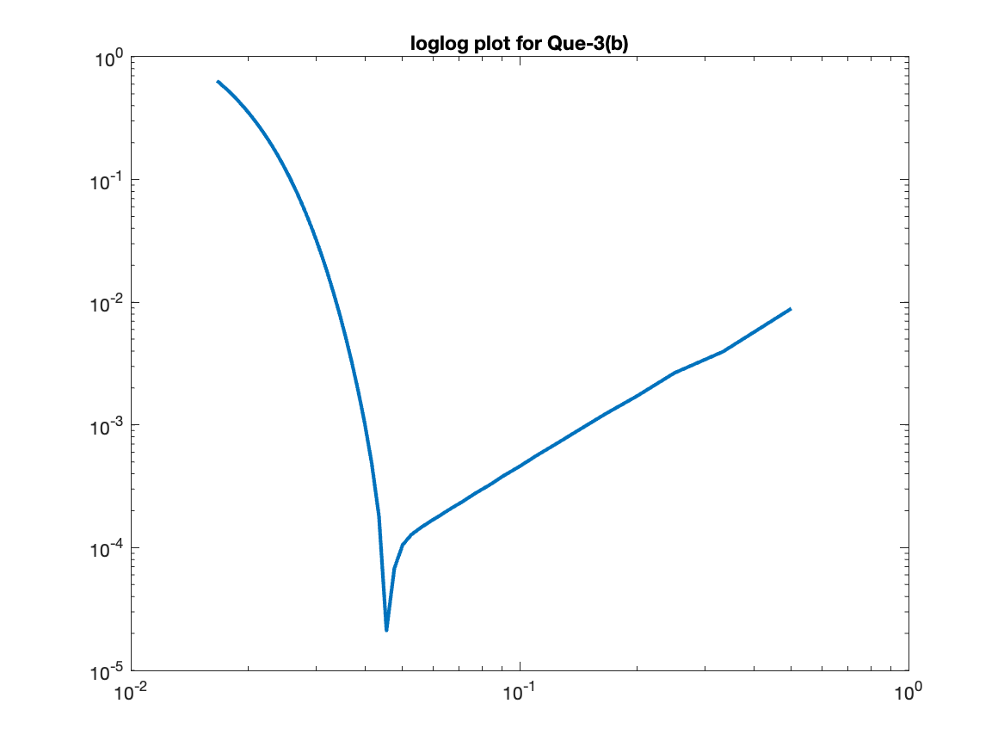

# Ques – 4

By using the FTCS method, BTCS method and the Crank-Nicolson method, the given BVPs are estimated. The **surface plot of exact solutions** is plotted once for both the parts and the following 3 plots are plotted for each method in both the parts: -

* Surface plot of approximate solutions.
* Exact and approximate solutions plot at the final time level.
* delx vs Max Error plot on loglog scale.

Here, for all the matrices mentioned, the x-axis is increasing from left to right and the y-axis is increasing from top to bottom.

1. FTCS

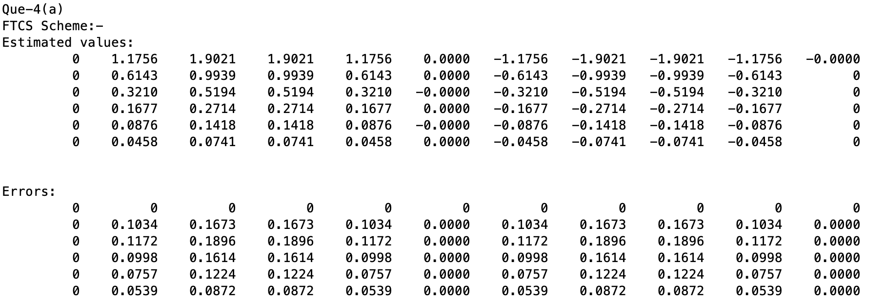

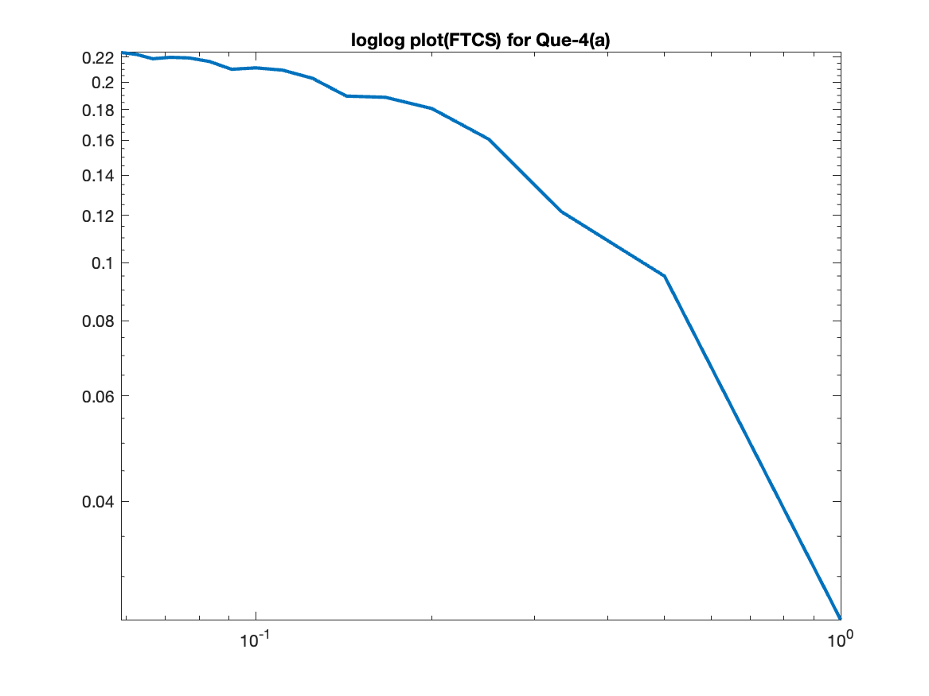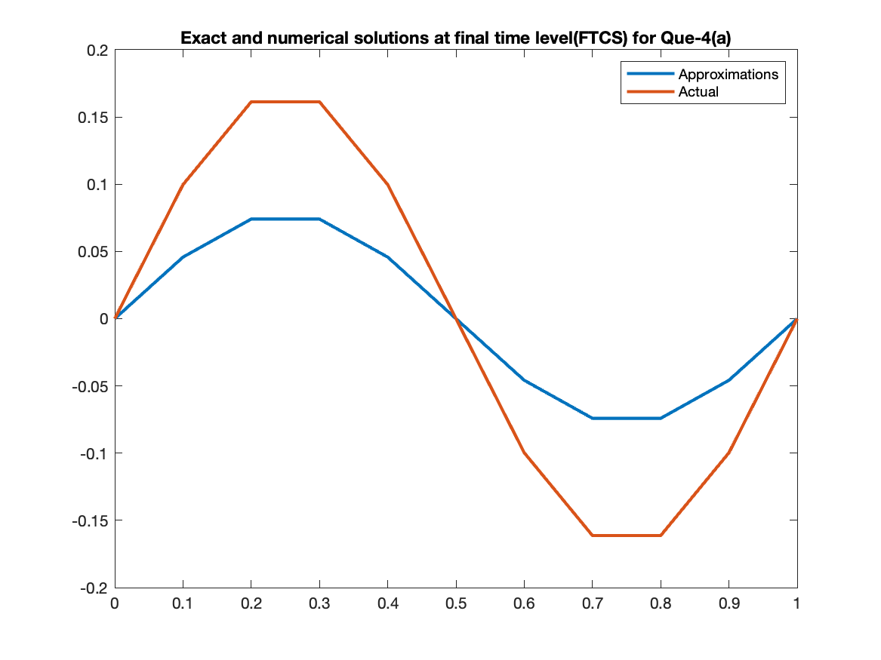

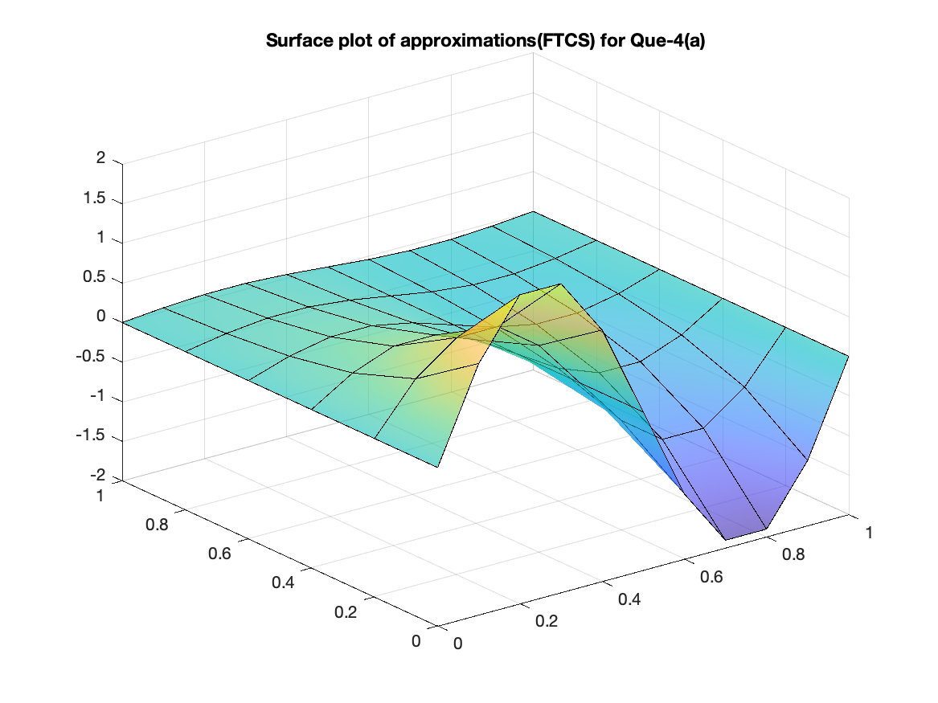

BTCS

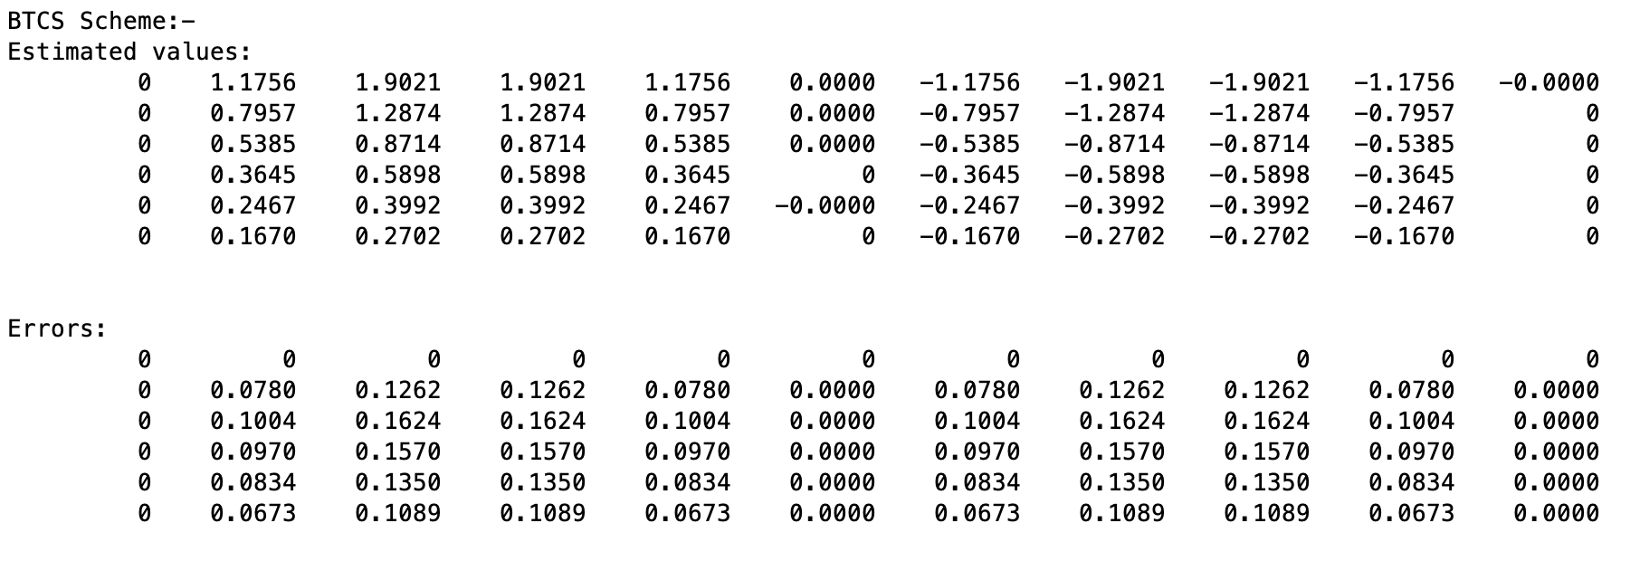

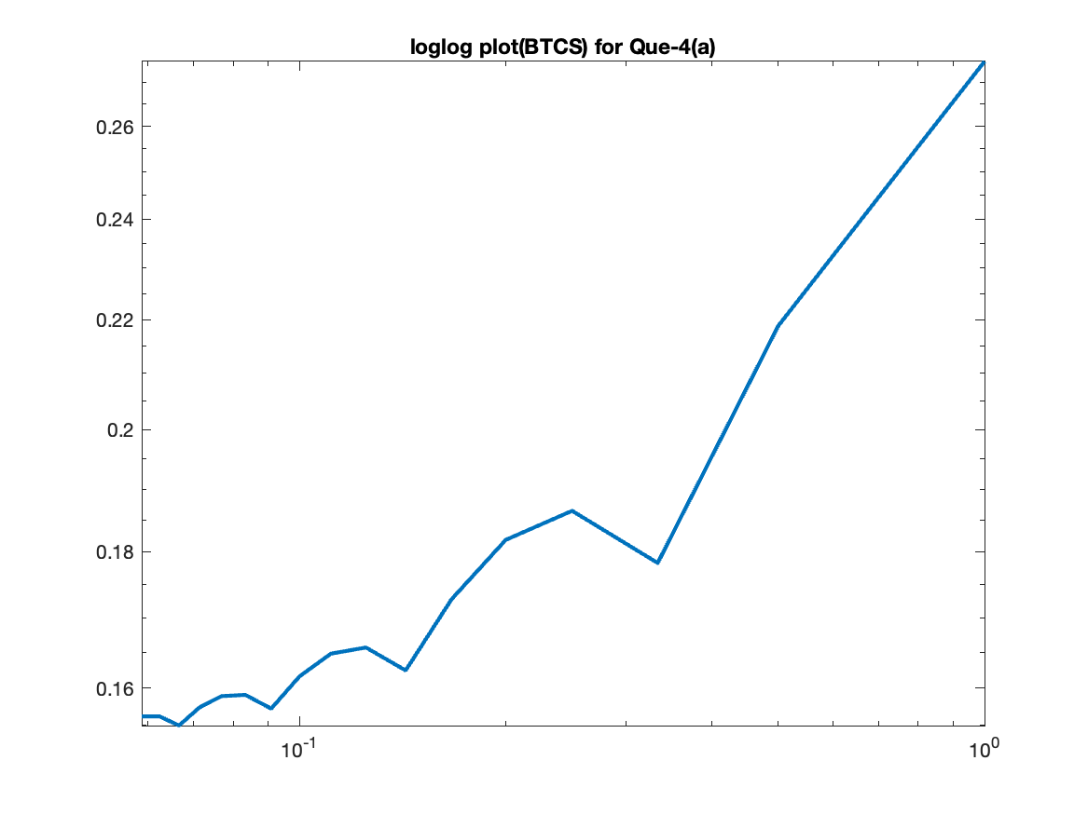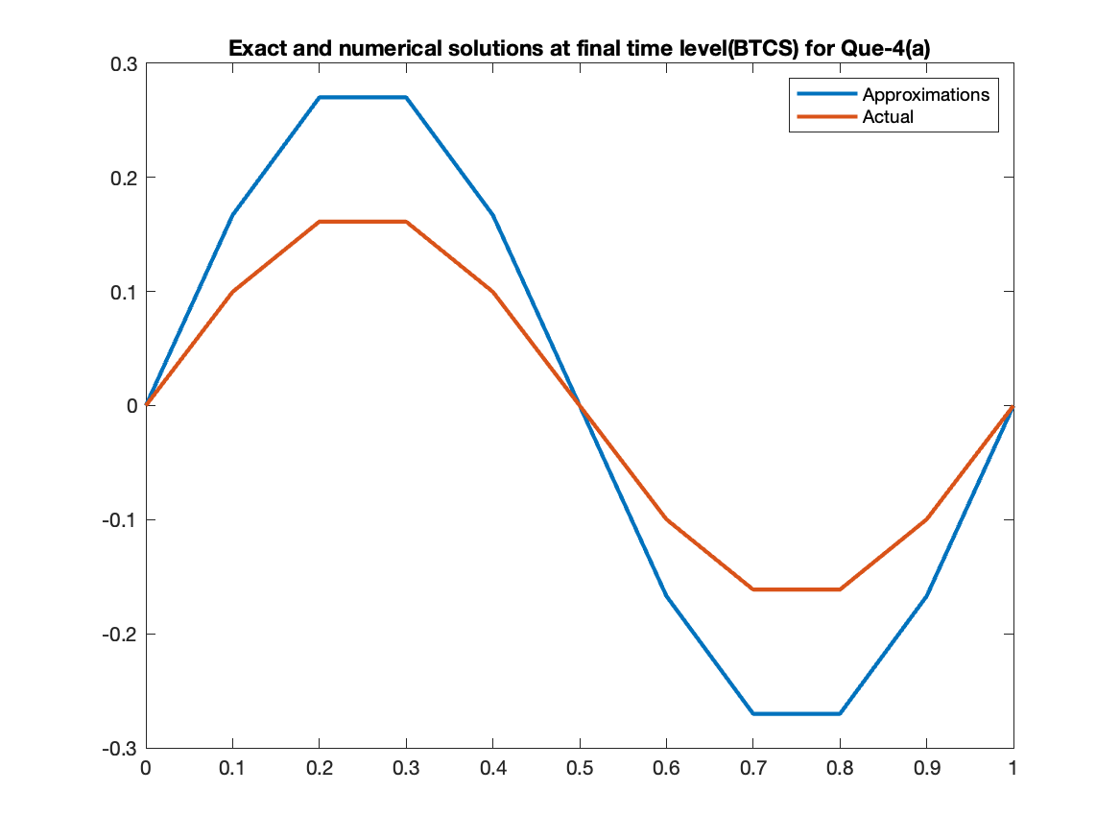

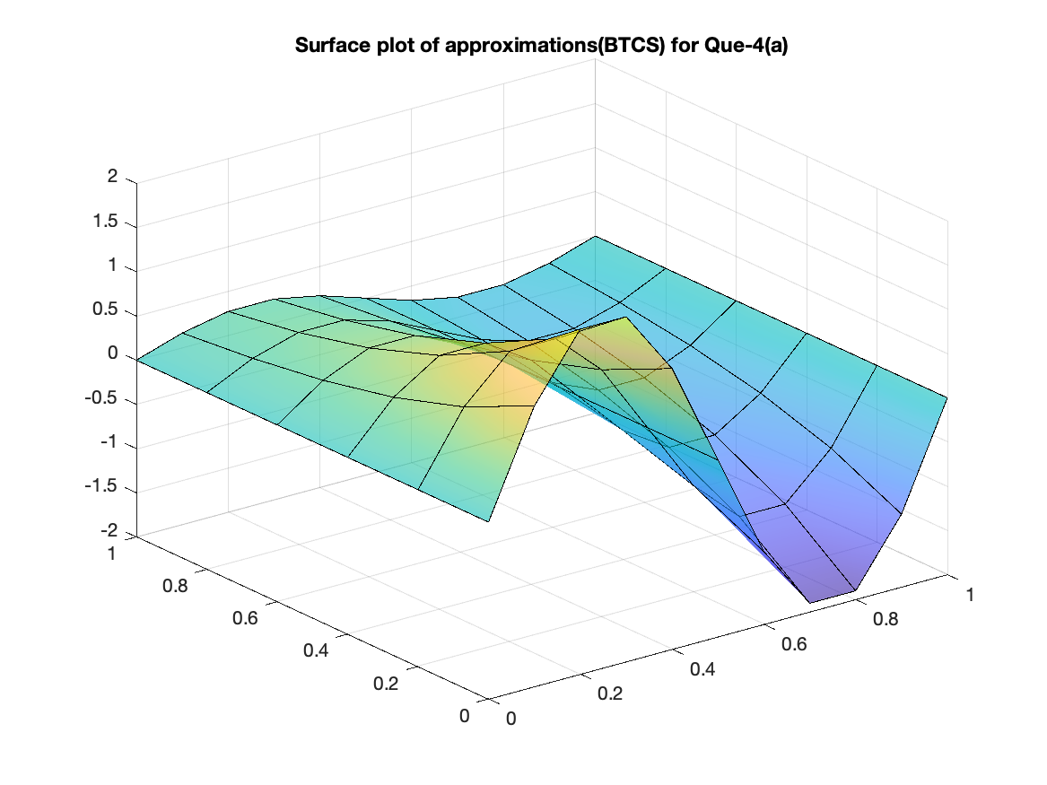

Crank-Nicolson

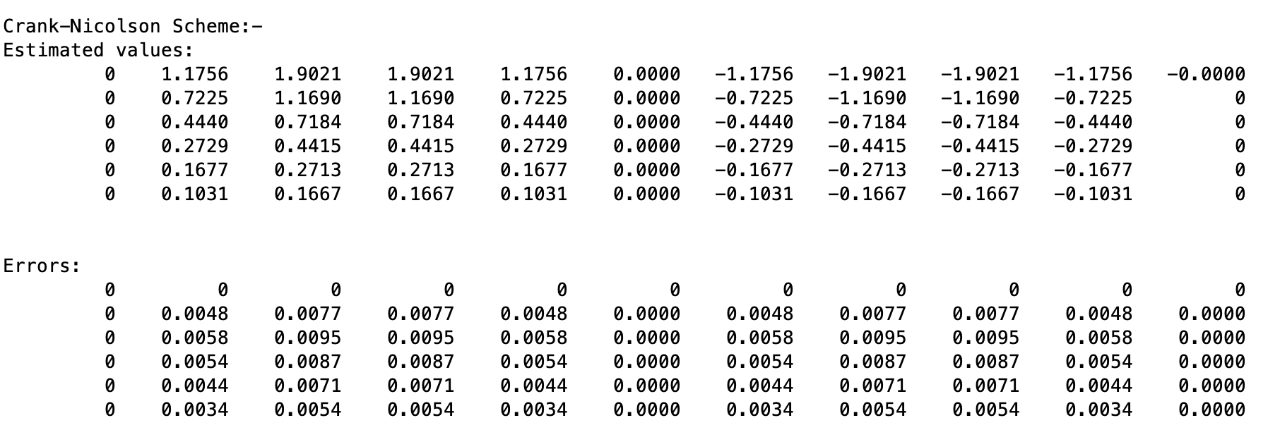

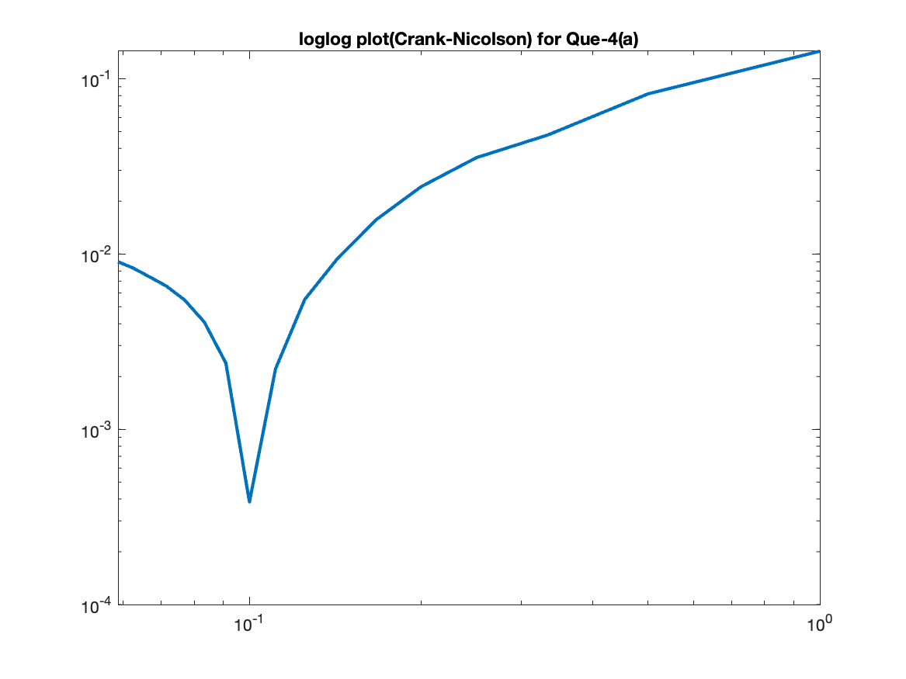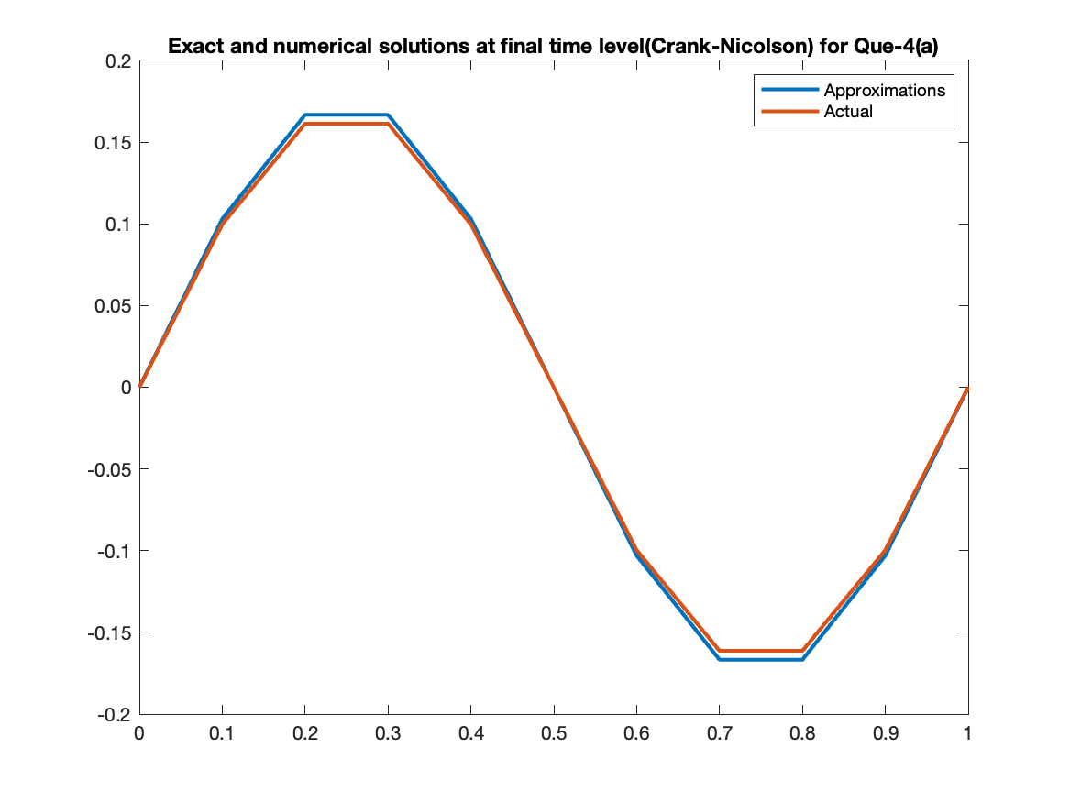

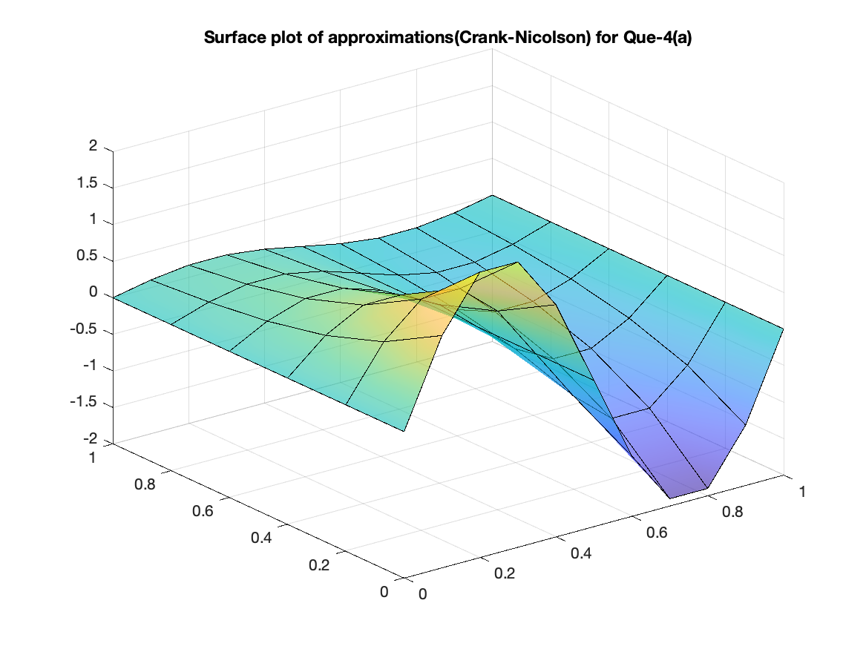

1. FTCS

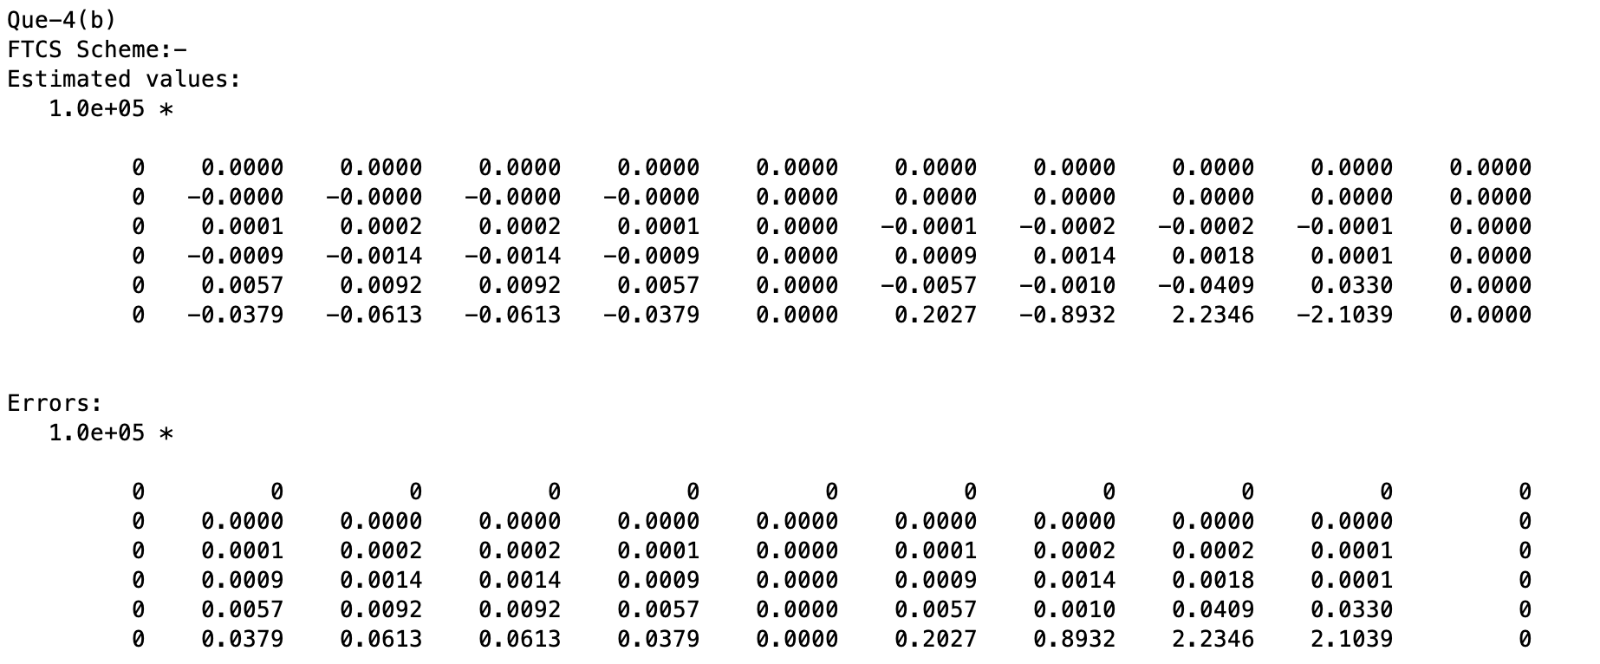

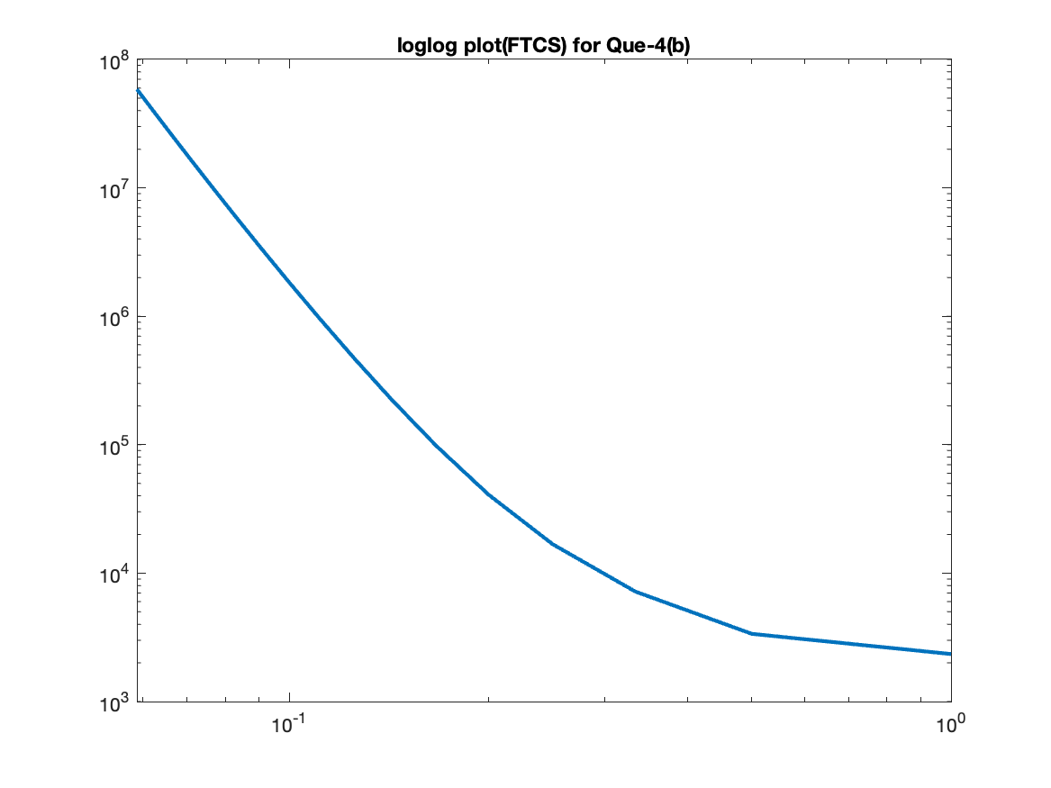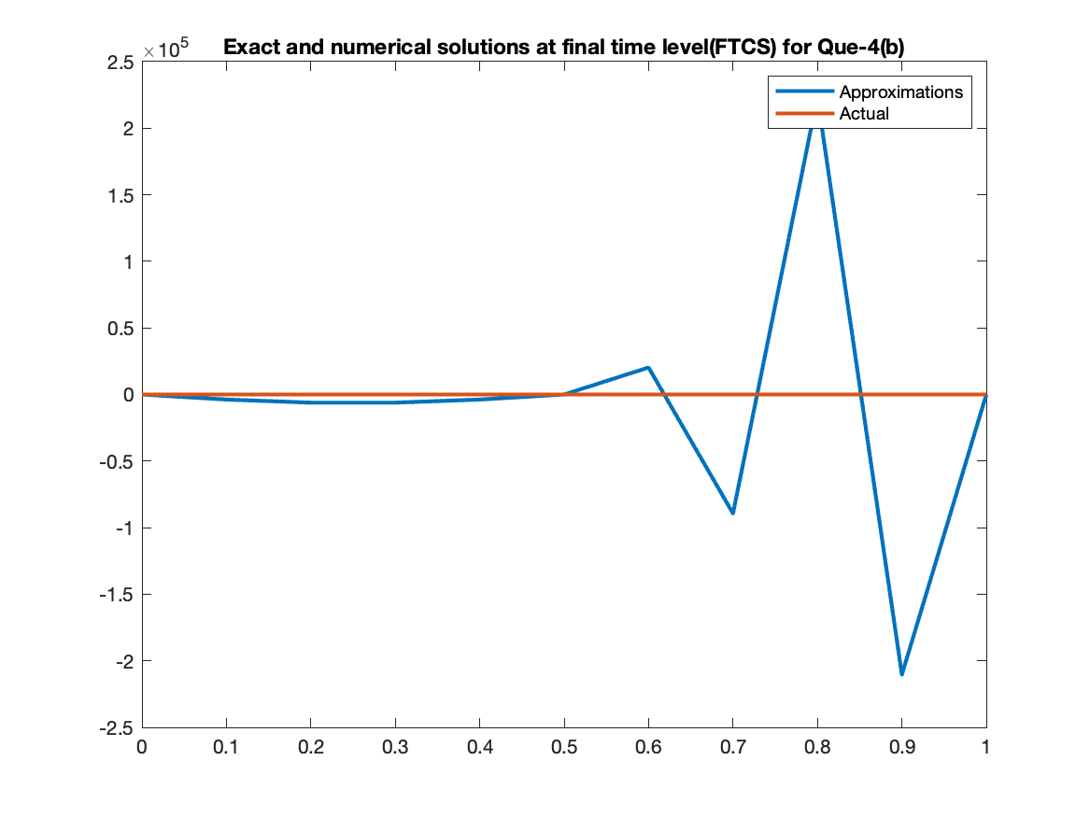

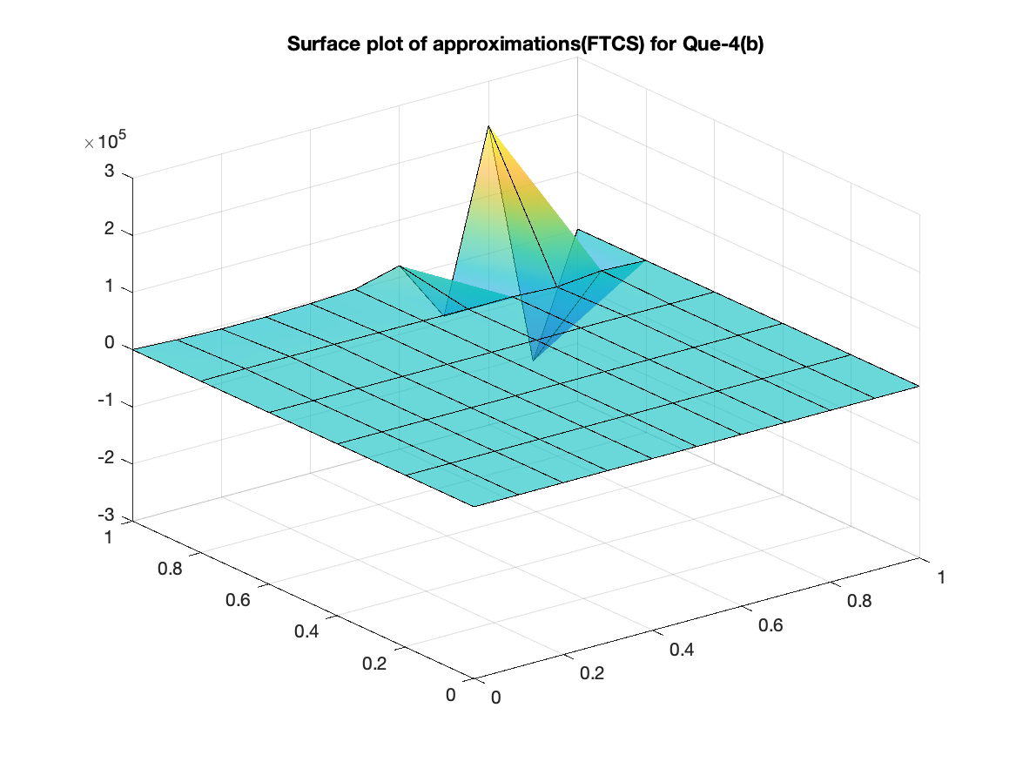

BTCS

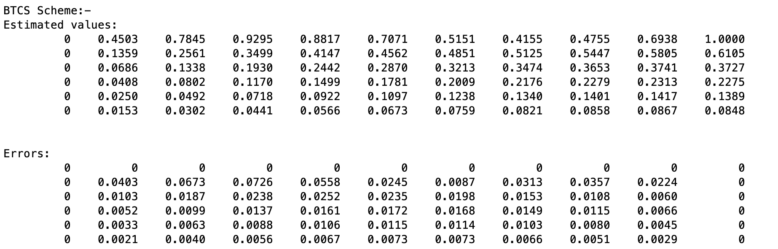

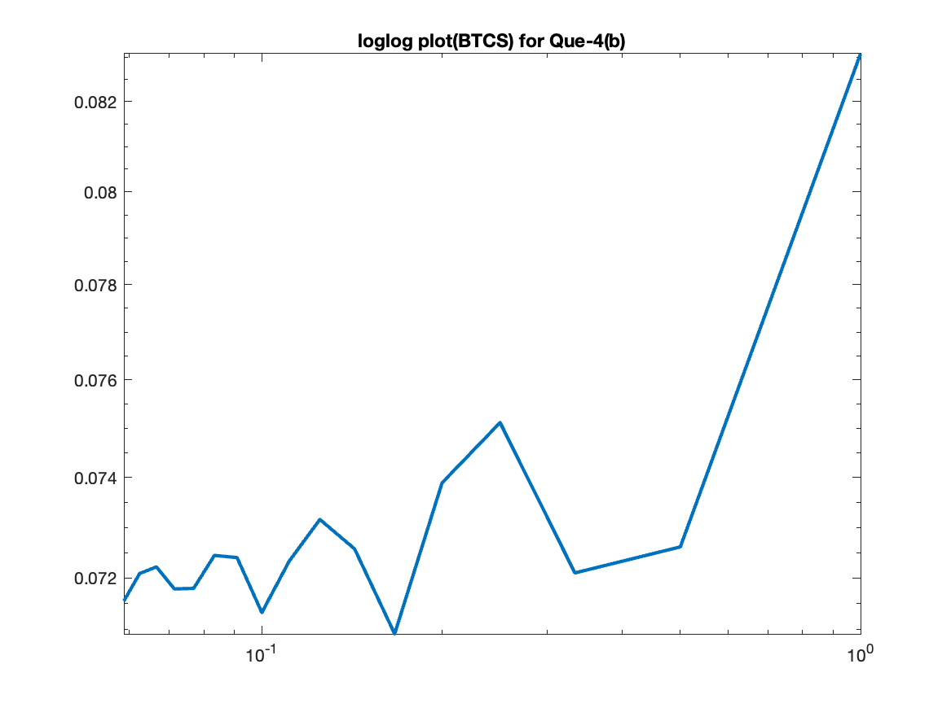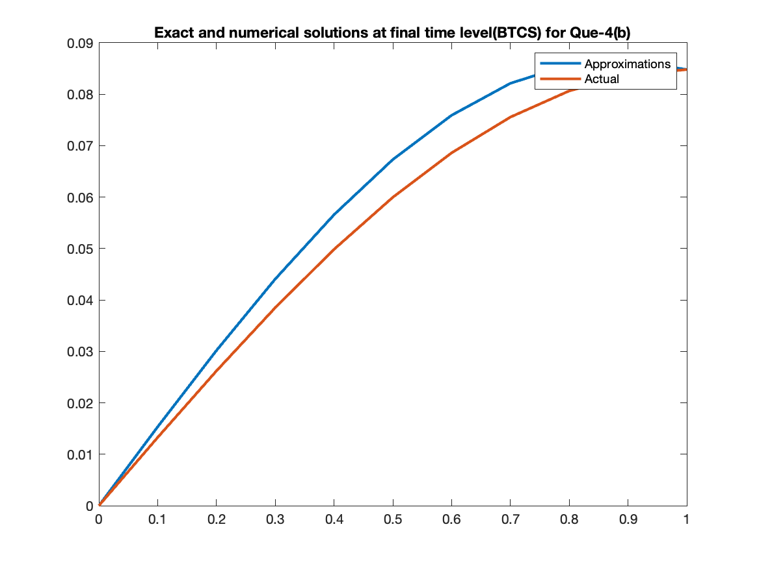

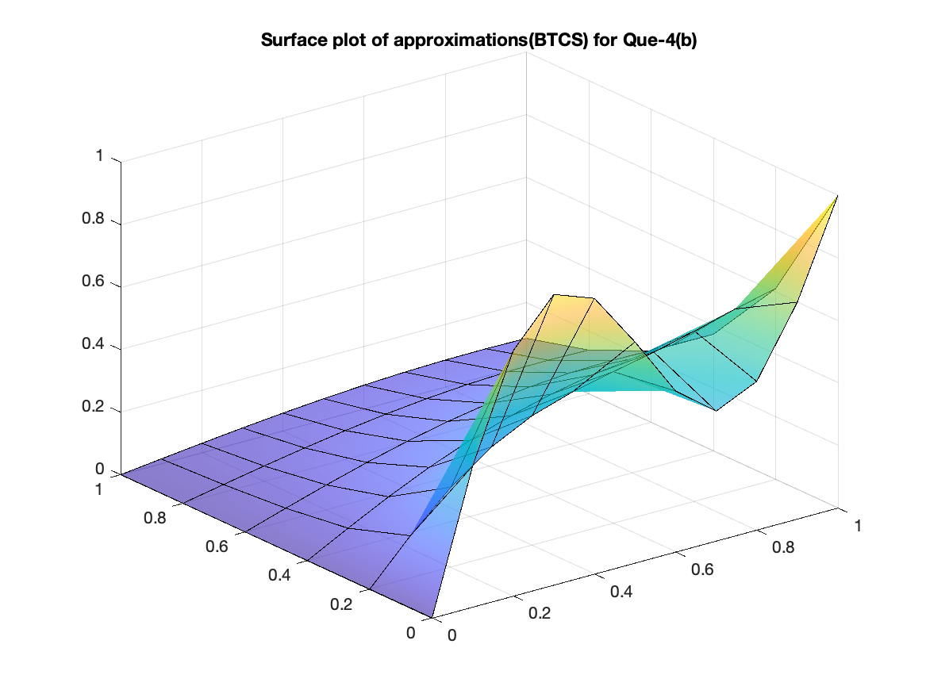

Crank-Nicolson

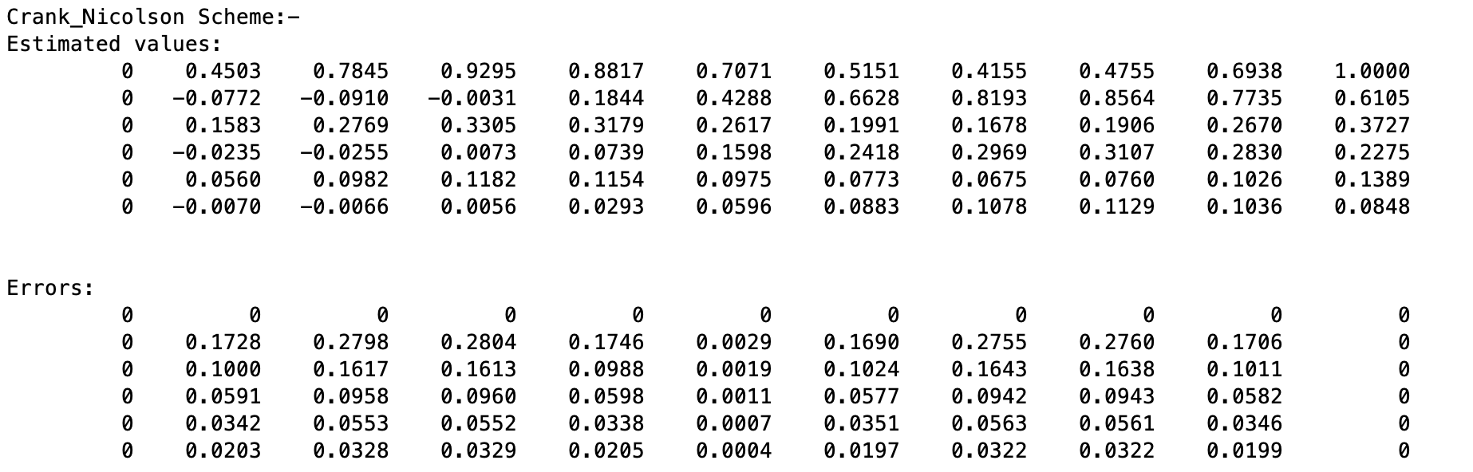

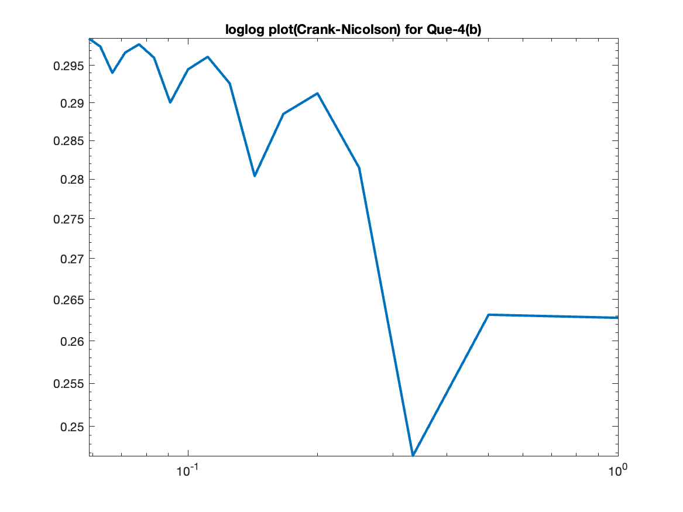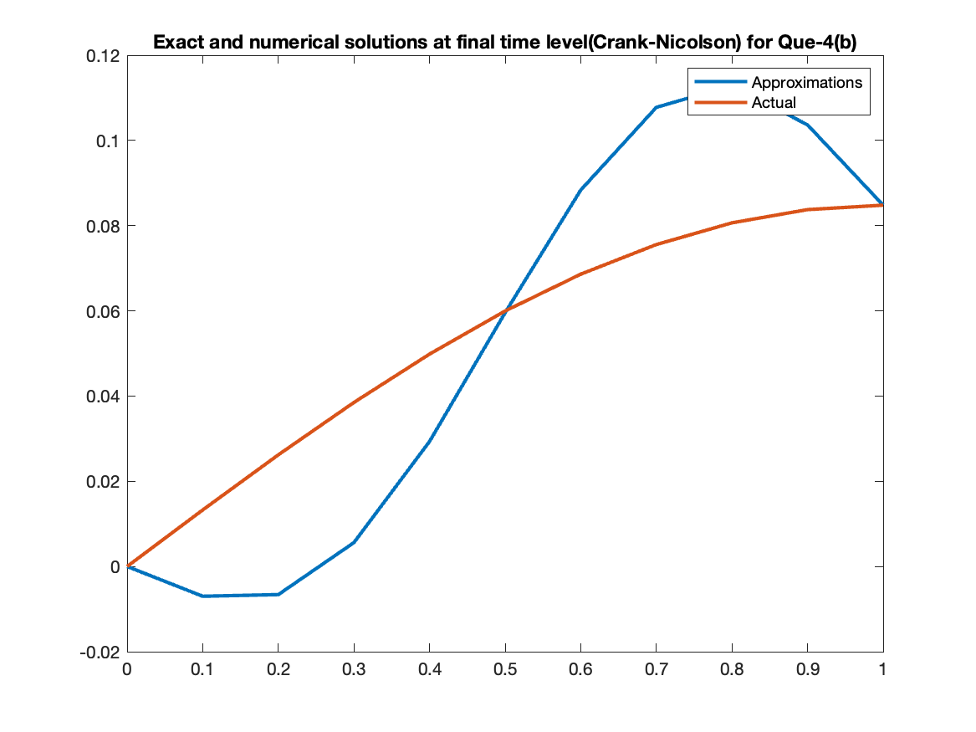

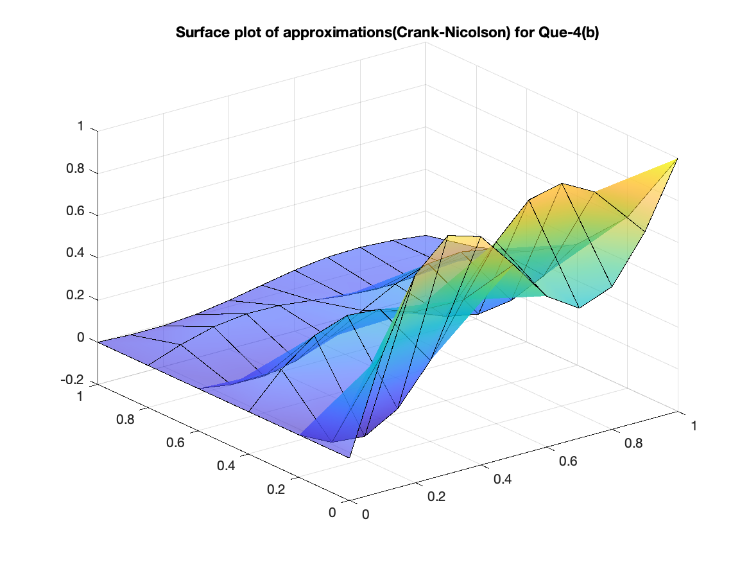

**Some Observations for Question-4**: -

* For part-(a), Crank-Nicolson scheme is providing the best estimate to actual solution, while for part-(b), BTCS scheme is doing that.
* In part-(b), FTCS scheme is severely failing, as we can observe that it is giving very high values (of order 105) than the actual solution stating that FTCS is not suitable here.
* For part-(b), Crank-Nicolson scheme is giving an oscillatory solution, this may be due to the noise from some extra unwanted term, making this scheme not suitable here.